 | 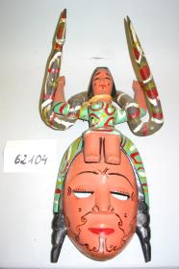
Inventory Number: | RJM 62104
Other number:
Title: | Mami
Artist/Participant: | Igbo
Provenance: | "Provenance (index card):  Origin (location book):  Nigeria"
Date:
Material/Technique:
Dimensions: | "Object dimensions: H 472 x W 240 x D/L 212 mm Weight: 456 g"
Location:
Acquisition manner:
Acquisition through:
Acquisition by:
Year of acquisition:
Acquisition note:
Description:
Notes: | Comparative literature: Wendl, Tobias. ' Mami Wata or a Cult between Cultures.' Kulturanthropologische Studien vol. 19. Münster 1991.
Literature:
Add. p. 38-45

Weitere Bilder
Bild
Bild | 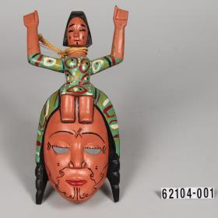
Bild | 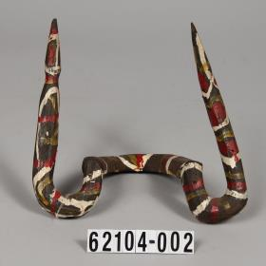
Bild | 